**STOCK PRICE PREDICTION PROJECT REPORT**

**Submitted by**

**HIMANSHU KUMAR SINGH [RA2011047010137]**

**RISHI ASLALIYA[RA2011047010100]**

**ROHAN CHAUHAN[RA2011047010109]**

                                                     Under the guidance of

**Dr.Rakesh Kumar M**

(Assistant Professor, Department of Computational Intelligence)

                                     in partial fulfillment for the award of the degree

                                                                 Of

**BACHELOR OF TECHNOLOGY**

                                                                  in

**COMPUTATIONAL INTELLIGENCE**

                                                                  of

**FACULTY OF ENGINEERING AND TECHNOLOGY**



**S.R.M. Nagar, Kattankulathur, Chengalpattu District**

**JUNE 2022**

**SRM INSTITUTE OF SCIENCE AND TECHNOLOGY**

**(Under Section 3 of UGC Act, 1956)**

**BONAFIDE CERTIFICATE**

Certified that this project report titled **“STOCK PRICE PREDICTION”** is the bonafide work of **“HIMANSHU KUMAR SINGH[RA2011047010137], RISHI ASLALIYA[RA2011047010100], ROHAN CHAUHAN[RA2011047010109]”**, who carried out the project work under my supervision. Certified further, that to the best of my knowledge the work reported herein does not form any other project report or dissertation on the basis of which a degree or award was conferred on an earlier occasion on this or any other candidate.

**SIGNATURE                                                                            SIGNATURE**

Dr.RAKESH KUMAR M                                                            Dr. ANNIE UTHRA

**GUIDE                                                                                     HEAD OF THE DEPARTMENT**

Assistant Professor                                                                  Dept. of Computational Intelligence

Dept. of Computational Intelligence

Signature of the Internal Examiner                                    Signature of the ExternalExaminer

**ACKNOWLEDGEMENTS**

 I would like to express my deepest gratitude to my guide,**Dr.Rakesh Kumar M**, his valuable guidance, consistent encouragement, personal caring, timely help and providing me with an excellent atmosphere for doing the project. All through the work, in spite of his busy schedule, he has extended cheerful and cordial support to me for completing this project work.

**HIMANSHU KUMARSINGH**

**RISHI ASLALIYA**

**ROHAN CHAUHAN**

**ABSTRACT**

Stock price prediction is one among the complex machine learning problems. It depends on a large number of factors which contribute to changes in the supply and demand. This paper presents the technical analysis of the various strategies proposed in the past, for predicting the price of a stock, and evaluation of a novel approach for the same. Stock prices are represented as time series data and neural networks are trained to learn the patterns from trends. Along with the numerical analysis of the stock trend, this research also considers the textual analysis of it by analyzing the public sentiment from online news sources and blogs. Utilizing both this information, a merged hybrid model is built which can predict the stock trend more accurately.

**CHAPTER 1**

**INTRODUCTION**

Stock price is the price of a single stock among the number of stocks sold by a company listed in public offering. Having stocks of a public company allows you to own a portion of it. Original owners of the company initially sell the stocks to get additional investment to help the company grow. This initial offering of stocks to the public is called Initial Public Offering (IPO). Stock prices change because of the supply and demand. Suppose, if many people are willing to buy a stock, then the price goes up as there is more demand. If more people are willing to sell the stock, the price goes down as there is more supply than the demand. Though understanding supply and the demand is relatively easy, it is hard to derive what factors exactly contribute to the increase in demand or supply. These factors would generally boil down to socioeconomic factors like market behavior, inflation, trends and more importantly, what is positive about the company in the news and what’s negative.Predicting the accurate stock price has been the aim of investors ever since the beginning of the stock market. Millions of dollars worth of trading happens every single day, and every trader hopes to earn profit from his/her investments. Investors who can make right buy and sell decisions will end up in profits. To make right decisions, investors have to judge based on technical analysis, such as company’s charts, stock market indices and information from newspapers and microblogs. However, it is difficult for investors to analyze and forecast the market by churning all this information. Therefore, to predict the trends automatically, many Artificial Intelligence (AI) techniques have been investigated. Some of the first research in prediction of stock prices dates back to 1994, in which a comparative study with machine learning regression models was performed. Since then, many researchers were investing resources to devise strategies for forecasting the price of the stock.

**Motivation :**

Efficient Market Hypothesis is one of the popular theories in financial economics. Prices of the securities reflect all the information that is already available and it is impossible to outperform the market consistently. There are three variants of Efficient Market Hypothesis (EMH); namely weak form, semi-strong form and the strong form. Weak form states that the securities reflect all the information that is publicly available in the past. Semi Strong form states that the price reflects all the publicly available data and also, they change instantly to reflect the newly available information. The strong form would include even the insider or private information.But this theory is often disputed and highly controversial. The best example would be investors such as Warren Buffet, who have earned huge profits over long period of time by consistently outperforming the market. Even though predicting the trend of the stock price by manually interpreting the chaotic market data is a tedious task, with the advent of artificial intelligence, big data and increased computational capabilities, automated methods of forecasting the stock prices are becoming feasible. Machine learning models are capable of learning a function by looking at the data without explicitly being programmed. But unfortunately, the time series of a stock is not a function that can be easily mapped. It can be best described more as a random walk, which makes the feature engineering and prediction much harder. With Deep Learning, a branch of machine learning, one can start training using the raw data and the features will be automatically created when neural network learns. Deep Learning echniques are among those popular methods that have been employed, to identify the stock trend from large amounts of data but until now there is no such algorithm or model which could consistently predict the price of future stock value correctly. Lot of research is going on both in academia and industry on this challenging problem.

**PROPOSED SOLUTION:**

Attribute such as: price of open, high, low, close, adjusted close price taken from huge dataset are fed as input to the models for training to pre-process the data techniques like normalization & one hot encoding in applied on dataset. After this data is divided in two sets namely training & testing which are ratio of 80:20 respectively. Then, this set are used to train a model using 3 different approaches: LSTM, CNN and Hybrid approach of LSTM+CNNS. Finally, all these modules are evaluated using Root mean square error.

**CHAPTER - 2**

**LITERATURE SURVEY**

**Stock Price Forecasting Using Data From Yahoo Finance and Analysing Seasonal and**

**Nonseasonal Trend:**

Publication Year: 2018

Author: Jai Jagwani, Hardik Sachdeva, Manav Gupta, Alka Singhal

Journal Name: 2018 IEEE

Summary: To identify the relationship between different existing time series algorithms

namely ARIMA and Holt Winter and the stock prices is the main objective of the proposed

work, for the investments a good risk-free range of stock prices are analyzed and therefore

better accuracy of the model can be seen. To find distinguished results for shares in the stock

market, the combination of two different time series analysis models is opted by producing a

range of prices to the consumer of the stocks. Not complex in nature and estimation of values

which are purely based on the past stock prices for non-seasonal or seasonal is the main

advantage of these models. In this experiment, some limitations are, the work that never takes

into consideration and other circumstances like news about any new market strategy or media

release relevant to any company which may get affected by the prices of stocks.

**Stock Market Prediction Using Machine Learning:**

Publication Year: 2018

Author: Ishita Parmar, Ridam Arora, Lokesh Chouhan, Navanshu Agarwal, Shikhin Gupta,

Sheirsh Saxena, Himanshu Dhiman

Journal Name: 2018 IEEE

Summary: In this paper studies, the use of Regression and LSTM based Machine learning

to forecast stock prices. Factors measured are open, close, low, high and volume. This paper

was an attempt to determine the future prices of the stocks of a company with improved

accuracy and reliability using machine learning techniques. LSTM algorithm resulted in a

positive outcome with more accuracy in predicting stock prices.

**Multi-Category Events Driven Stock Price Trends Prediction:**

Publication Year: 2018

Author: Youxun Lei, Kaiyue Zhou, Yuchen Liu

Journal Name: 2018 IEEE

Summary: In this paper, multi-category news events are used as features to develop stockprice trend prediction, model. The multi-category events are based on already defined featureword dictionary. And we have employed both neural networks and SVM models to analyse therelationship between stock price movements and specific multi-category news. Experimentalresults showed that the predefined multi-category news events are more improved than thebaseline bag-of-words feature to predict stock price trend. As compared to long termprediction, short term prediction is better based on this study

**Share Price Prediction using Machine Learning Technique:**

Publication Year: 2018

Author: Jeevan B, Naresh E, Vijaya kumar B P, Prashanth Kambli

Journal Name: 2018 IEEE

Summary: This paper is mostly based on the approach of predicting the share price usingLong Short Term Memory (LSTM) and Recurrent Neural Networks (RNN) to forecast thestock value on NSE data using various factors such as current market price, price-earning ratio,base value and other anonymous events. The efficiency of the model is analysed by comparing the true data and the predicted data using an RNN graph. Machine learning to predict stock price as see the model is able to predict the stock price very close to the actual price where this model captures the detailed feature and uses different strategies to make a prediction. The model train for all the NSE data from the internet and recognize the input and group them and provide input according to the user configuration this RNN based architecture proved very efficient in forecasting the stock price by changing the configuration accordingly which also use backpropagation mechanism while gathering and grouping data to avoid mixing of data.  
  
  
  
**Stock Market Prediction Using Machine Learning Techniques:**

Publication Year: 2016

Author: Mehak Usmani, Syed Hasan Adil, Kamran Raza, Syed Saad Azhar Ali

Journal Name: 2016 IEEE

Summary: The prominent aim of this study is to forecast the market performance of the Karachi Stock Exchange (KSE) on day closing using machine learning algorithms. A variety of attributes as an input and forecasts market as Positive & Negative is predicted by using the predictions model. The features employed in the model are contains Oil rates, Gold & Silver rates, Interest rate, Foreign Exchange (FEX) rate, NEWS and social media feed. The machine learning algorithms including Single Layer Perceptron (SLP), Multi-Layer Perceptron (MLP), Radial Basis Function (RBF) and Support Vector Machine (SVM) are compared. The algorithm MLP that is multi-layer perceptron performed best as compared to different methods. The foremost helpful feature in predicting the market was the oil rate attribute. The end results of this research confirm that machine learning techniques have the ability to predict the stock market performance. The Multi-Layer Perceptron algorithm of machine learning predicted 70% correct market performance.

**Forecasting stock price in two ways based on LSTM neural network:**

Publication Year: 2019

Author: Jingyi Du, Qingli Liu, Kang Chen, Jiacheng Wang

Journal Name: 2019 IEEE

Summary: The LSTM neural network is used to predict Apple stocks by consuming single feature input variables and multi-feature input variables to verify the forecast effect of the model on stock time series. The experimental results show that the model has a high accuracy of 0.033 for the multivariate input and is accurate, that is in line with the actual demand. For the univariate feature input, the predicted squared absolute error is 0.155, which is inferior to the multi-feature variable input.

**Share Price Trend Prediction Using CRNN with LSTM Structure:**

Publication Year: 2018

Author: Shao-En Gao , Bo-Sheng Lin ,Chuin-Mu Wang

Journal Name: 2018 IEEE

Summary: The entire financial market majorly runs by the stock market and one of the most attractive research issues is predicting stock price volatility. The information of historical stocks for assuming the future stock price as well deep learning method is applied to find approximate trend value of stock prices which are mentioned in this paper. This paper not only stores the data of historical stock with the time scale but also estimates prices of the future stock by a designed neural network, this is due to the fact that the trend of stocks is usually connected to the previous information of stock price. In this paper, the design of the neural network proposed then with the memory performance the convolutional recurrent neural network (CRNN) and for improving the long-term dependency of traditional RNN the Long Short-term memory (LSTM) are the major components. Also to enhance the accuracy as well as stability of prediction of the RNN LSTM architecture is put. This paper accumulates a total of ten stock historic data to test and accomplish an average error rate of 3.449 RMSE.

**Applying Long Short Term Memory Neural Networks for Predicting Stock Closing**

**Price:**

Publication Year: 2017

Author: Tingwei Gao, Yueting Chai, Yi Liu

Journal Name: 2017 IEEE

Summary: To assess the scheme that merges RNNs with informative input variables which can give an improved and effective method to forecast the next-day market is the main objective of this paper. The stock prediction model analyses using long-short memory (LSTM) and stock basic trading data. On Standard & Poor’s (S&P500) and NASDAQ, the case study relies. The stock closing price is more precisely predicted using their forecasting system for the next day, which outperforms the comparison models. This is the main discovery of the case study. Five various models namely – moving average (MA), exponential moving average (EMA), support vector machine (SVM) and LSTM are tested by them to demonstrate the utility of the system. The closing value of the next day is the predicting target.  
  
 **Developing a Prediction Model for Stock Analysis:**

Publication Year: 2017

Author: R. Yamini Nivetha, Dr. C. Dhaya

Journal Name: 2017 IEEE

Summary: A relative study of the three algorithms namely - Multiple Linear Regression(MLR), Support Vector Machine (SVM) and Artificial Neural Network (ANN) is the main aim of this study. To predict the coming day market price, the prediction will be determined by monthly prediction and daily prediction. Sentiment analysis with the best prediction algorithm forecast the stock price. The less-developed algorithm is the Multiple Linear Regression algorithm which calculates the correlation between volume and the stock price. The result of the study shows that deep learning algorithms are more developed than MLR algorithms and SVM algorithm.

**Stock Price Prediction Based on Information Entropy and Artificial Neural Network:**

Publication Year: 2019

Author: Zang Yeze, Wang Yiying

Journal Name: 2019 IEEE

Summary: One of the most important components of the financial system is the stock market. [11] For supporting the activity and evolvement, money is directed by the investors of the associated frim. Along with information theory and Artificial Neural Network (ANN) the combination of machine learning framework is formed. Information entropy for non-linear causality and stock relevance also to facilitate ANN time series modelling are creatively used by this method. The feasibility of this machine learning framework is analysed with Amazon, Apple, Google and Facebook prices. A time series analysis method based on information theory as well as LSTM to model the stock price dynamics are outlined in this paper. The transfer entropy between relevant variables to help LSTM time series prediction is merged in this modelling infrastructure, thus the accuracy of the assumption outcome is broadly granted. Modelled and real stock price is highly correlated while differ slightly in terms of Mean Absolute Error (MAE) and Root Mean Square Error (RMSE) which are investigated by the outcomes  
  
  
**Summary of Literature Survey:**

Here, I have reviewed various approaches for Stock price prediction. All approaches have

their own advantages and disadvantages. CNN & LSTM is a most popular algorithm to

prediction the stock price but there are some challenges in this method like use to need a lot

of training data, High computational cost, without GPU data quite slow to train, depend on

any previous information for prediction. A hybrid approach can be used to overcome these

issues. While machine learning is able to provide highly accurate prediction result using

standards tools and also outperforms all standard prediction methods.

**CHAPTER - 3**

**Proposed work**

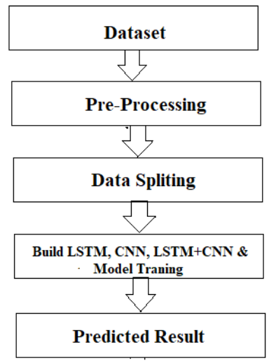

The system presented here composes of five modules:-

1. Input as Dataset

2. Pre processing

3. Data splitting

4. Build & Model train Lstm, CNN and Hybrid approach of LSTM+CNN

5. Output as Predicted Result

Attribute such as: price of open, high, low, close, adjusted close price taken from huge dataset are fed as input to the models for training to pre-process the data techniques like normalization & one hot encoding in applied on dataset. After this data is divided in two sets namely training & testing which are ratio of 80:20 respectively. Then, this set are used to train a model using 3 different approaches: LSTM, CNN and Hybrid approach of LSTM+CNNS. Finally, all these modules are evaluated using Root mean square error.

**Working of LSTM model**

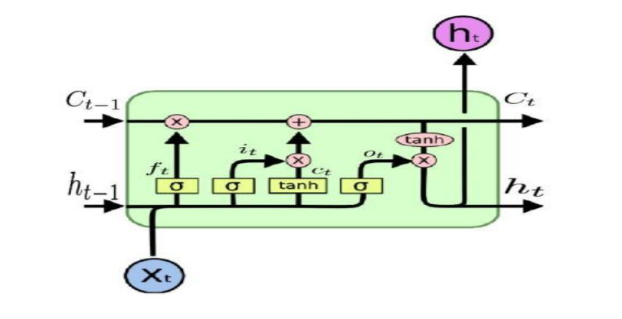

Long Short Term Memory is a kind of recurrent neural network. In RNN output from the last

step is fed as input within the present step. It tackled the matter of long-term dependencies of

RNN within which the RNN will not predict the word hold on within the long term memory

however can offer additional accurate forecasts from the recent info. Because the gap length

will increases RNN does not offer an economical performance. LSTM will by default retain

the knowledge for a long period of time. It is used for processing, predicting and classifying

on the basis of time-series data.

* Structure of LSTM:
* LSTM has a chain organization that contains four neural networks and different memory
* blocks called cells.
* LSTM has a new structure called a memory cell. The memory cell makes the decisions about
* what information to store, and when to allow reading, writing and forgetting.
* A memory cell contains three main gates:

Input gate- a new value flows into the memory cell.

Forget gate- a value remains in the memory cell.

Output gate- value in the memory cell is used to compute the output

Applications of LSTM includes:

* Language Modelling
* Machine Translation
* Image Captioning
* Handwriting generation
* Question Answering Chatbot

**Working of CNN model**

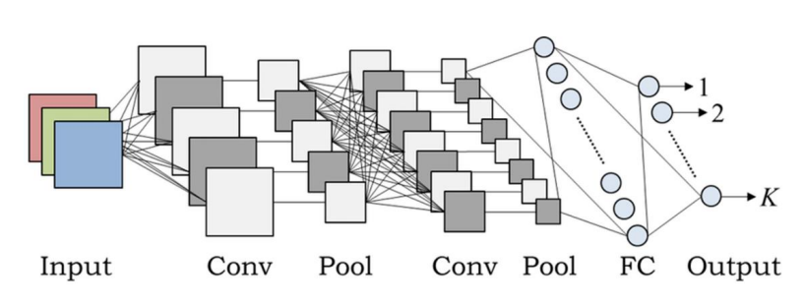

Layer of CNN model:

* Convolution
* MAX Pooling
* Dropout
* Flatten
* Dense
* Activation
* Convolution:In the Convolution extract the featured from the input image. It given the output in matrix form.
* MAX Pooling: In the MAX polling it takes the largest element from a rectified feature map.
* Dropout: Dropout is randomly selected neurons are ignored during training.
* Flatten: Flatten feed output into a fully connected layer. It gives data in list form.
* Dense: A Linear operation in which every input is connected to every output by weight. It followed by a nonlinear activation function.
* Activation: It used sigmoid function and predict the probability 0 and 1.
* Applications of CNN includes:
* Decoding Facial Recognition
* Analyzing Documents

**Hybrid Approach of LSTM + CNN**

In the hybrid approach, the Convolutional Neural Networks (CNNs) offer benefits in choosing sensible options and Long Short-Term Memory (LSTM) networks have proven sensible skills to find out to learn sequential data. Each approaches are reported to produce improved result. CNNs to possess to convolute filters over every input layer so as to get the simple options and CNNs have shown enhancements in computer vision, natural language processing and different tasks . CNN may be a powerful tool to pick out features in order to improve the prediction accuracy . The capabilities of LSTMs in learning data series by considering the previous outputsThe multiple convolutional filters slide over the matrix to produce a new feature map and also the filters have numerous completely different sizes to generate different features. The Max pooling layer is to calculate the most value as a corresponding feature to a particular filter. The output vectors of the Max-pooling layer become inputs to the LSTM networks to measure the long-run dependencies of feature sequences. One in all the benefits of the LSTMs is that the ability to capture the sequential data by considering the previous data. This layer takes the output vectors from the dropout layer as inputs. This layer include a set number of units or cells and also the input of every cell is that the output from the dropout layer. The final output of this layer has the same number of units within the network the outputs from LSTMs are merged and combined in one matrix then passed to a fully connected layer. The array is converted into a single output in the range between 0 and 1 using the fully connected layer, in order to be finally classified using sigmoid function

**Chapter 4. Dataset, Tools & technologies**

**Dataset Detail**

The dataset consists of the stock historical data from the National stock exchange (NSE) and

captures the daily information of each stock from the National Stock Exchange. It collects

different sectors of stock data, including Banking, Pharma, Petroleum, Software and Textiles

and it including the opening price, the highest price, the lowest price, the closing price, the

adjusted closing price and the volume of stock

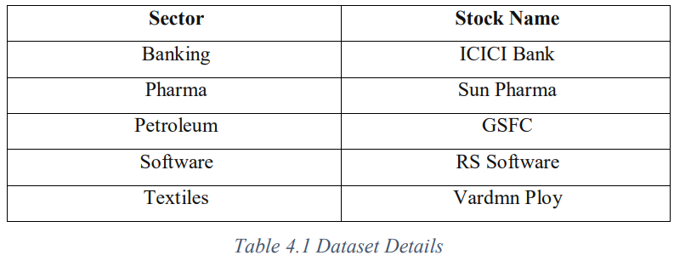

**Tool & Technologies**

PYTHON

The language of select for this project was Python. This was a straightforward call for many reasons.

1. Python [19] as a language has a vast community behind it. Any problems which may be faced is simply resolved with visit to Stack Overflow. Python is the foremost standard language on the positioning that makes it is very straight answer to any question.

2. Python [19] is an abundance of powerful tools ready for scientific computing Packages. The packages like NumPy, Pandas and SciPy area unit freely available and well documented. These Packages will intensely scale back, and variation the code necessary to write a given program. This makes repetition fast.

3. Python is a language as [19] forgiving and permits for the program that appear as if pseudo code. This can be helpful once pseudo code give in tutorial papers should be required and verified. Using python this step is sometimes fairly trivial. However, Python is [19] not without its errors. The python is dynamically written language and packages are area unit infamous for Duck writing. This may be frustrating once a package technique returns one thing that, for instance, looks like an array instead of being an actual array. Plus the standard Python documentation did not clearly state the return type of a method, this can’t lead without a lot of trials and error testing otherwise happen in a powerfully written language. This is a problem that produces learning to use a replacement Python package or library more difficult than it otherwise may be.

**NUMPY**

Numpy is python package which provide scientific and higher level mathematical abstractions wrapped in python. It is [20] the core library for scientific computing, that contains a provide tools for integrating C, strong n-dimensional array object, C++ etc. It is also useful in random number capability, linear algebra etc.Numpy’s array type augments the Python language with an efficient data structure used for numerical work, e.g., manipulating matrices. Numpy additionally provides basic numerical routines, like tools for locating Eigenvectors  
  
**SCIKIT LEARN**

Scikit-learn [21] could be a free machine learning library for Python. It features numerous classification, clustering and regression algorithms like random forests, k-neighbours, support vector machine, and it furthermore supports Python scientific and numerical libraries like SciPy and NumPy. In Python Scikit-learn is specifically written, with the core algorithms written in Cython to get the performance. Support vector machines are enforced by a Cython wrapper around LIBSVM .i.e., linear support vector machines and logistic regression by a similar wrapper around LIBLINEAR.

**TENSORFLOW**

In the TensorFlow [22]has an open source software library for numerical computation using data flow graphs. Inside the graph nodes represent mathematical formulae, the edges of graph represent the multidimensional knowledge arrays (tensors) communicated between them. The versatile architecture permits to deploy the computation to at least one or many GPUs or CPUs in a desktop, mobile device, servers with a single API. TensorFlow was firstly developing by engineers and researchers acting on the Google Brain Team at intervals Google's Machine Intelligence analysis organization for the needs of conducting deep neural networks research and machine learning, but, the system is generally enough to be appropriate in a wide range of alternate domains as well.Google Brain's second-generation system is TensorFlow. Whereas the reference implementation runs on single devices, TensorFlow can run on multiple GPUs and CPUs. TensorFlow is offered on Windows, macOS, 64-bit Linux and mobile computing platforms together with iOS and Android.  
  
  
  
  
**KERAS**

Keras is a high-level neural networks API, it is written in Python and also capable of running on top of the Theano, CNTK, or. TensorFlow. It was developed with attention on enabling quick experimentation. having the ability to travel from plan to result with the smallest amount doable delay is key to doing great research.Keras permits for straightforward and quick prototyping (through user-friendliness, modularity, and extensibility). Supports each recurrent networks and convolutional networks, also as combinations of the 2. Runs seamlessly on GPU and CPU. The library contains numerous implementations of generally used neural network building blocks like optimizers, activation functions, layers, objectives and a number of tools to create operating with text and image data easier. The code is hosted on GitHub, and community support forums embody the GitHub issues page, a Gitter channel and a Slack channel.

**CHAPTER – 5**

**RESULTS AND DISCUSSION**

**CODE IMPLEMENTAION:**

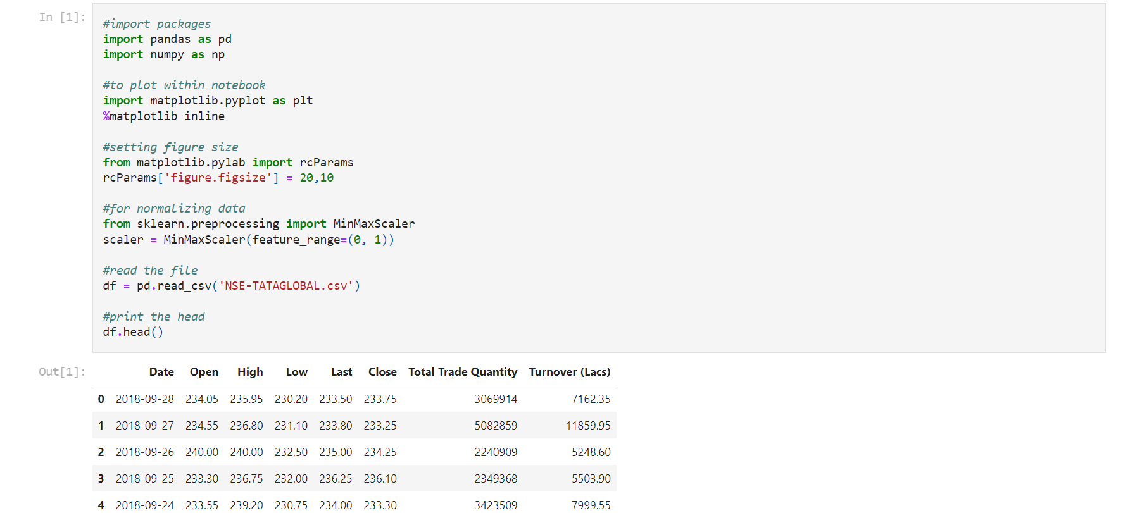

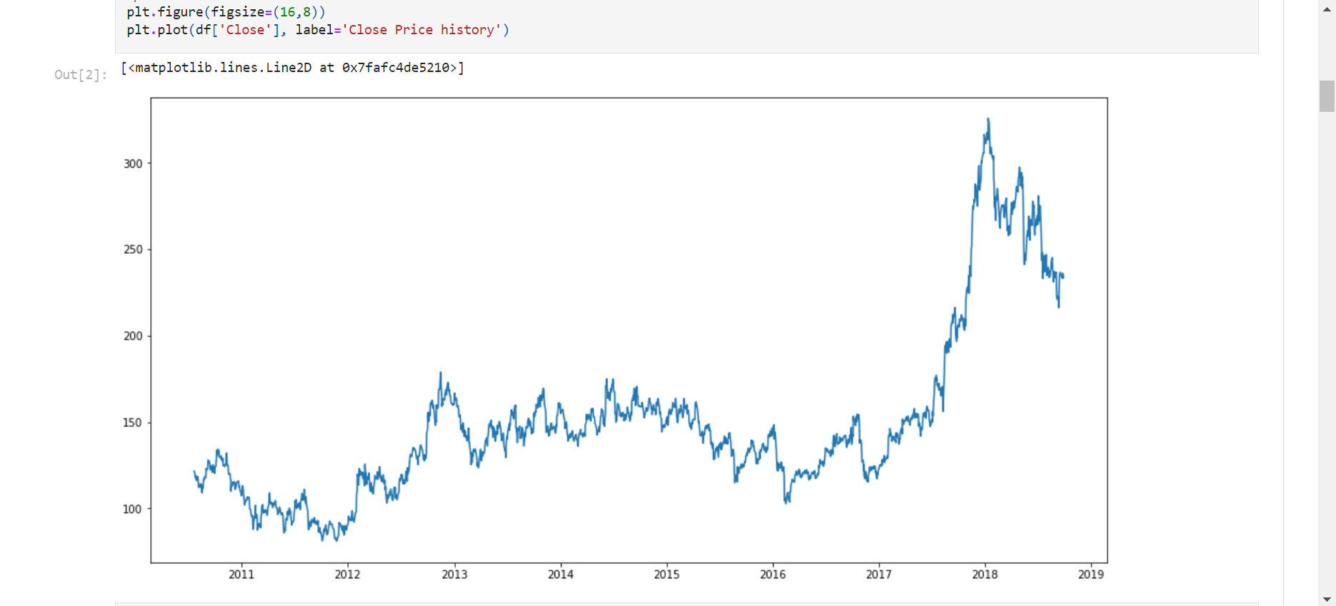

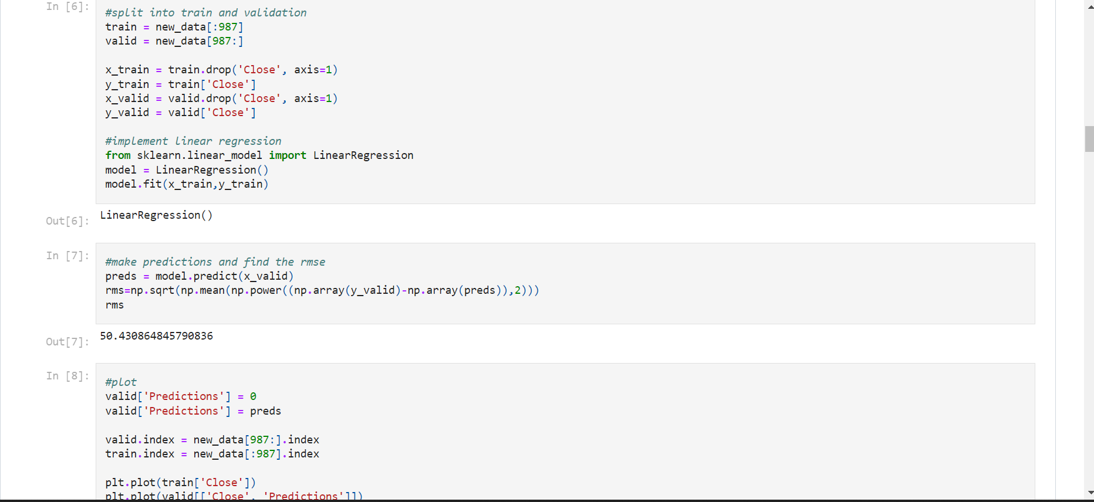

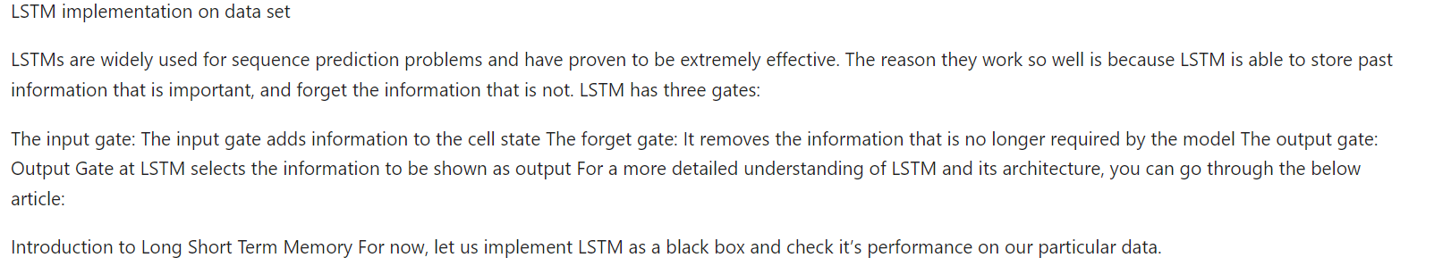

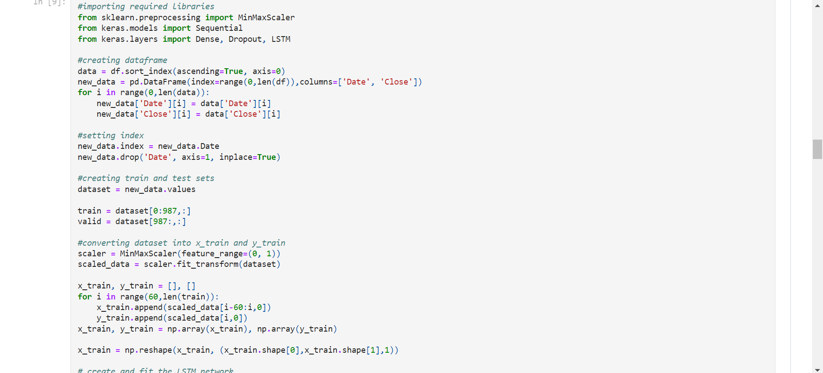

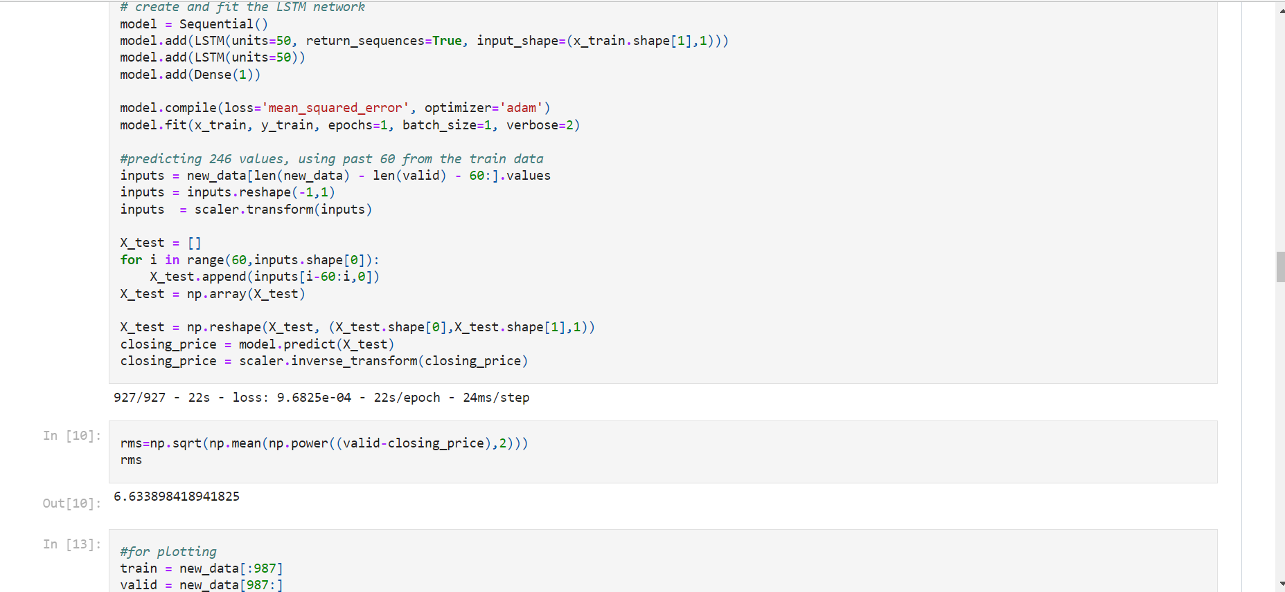

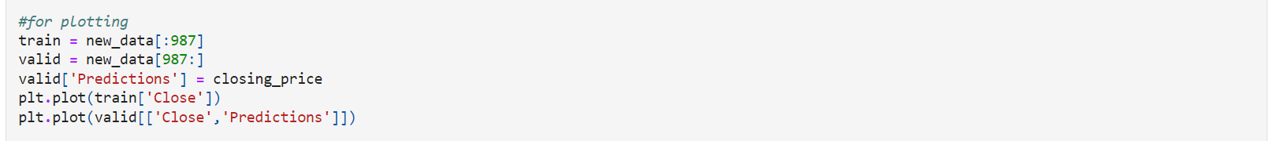

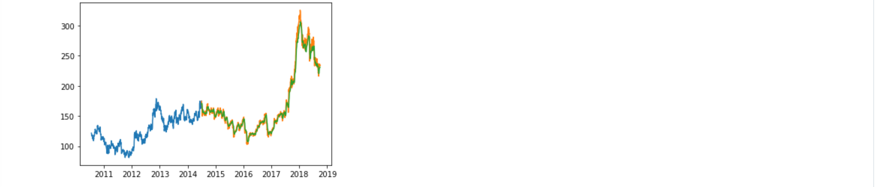

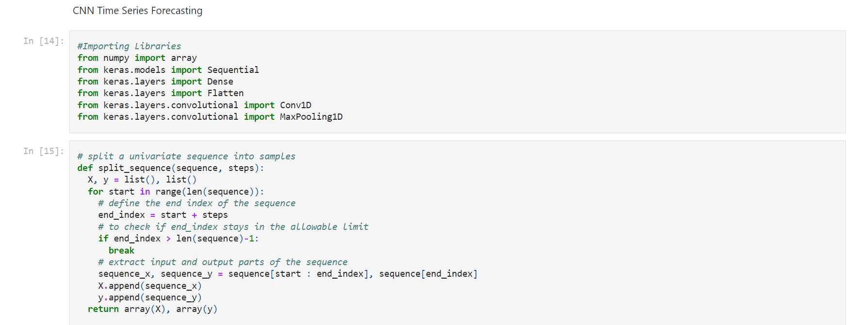

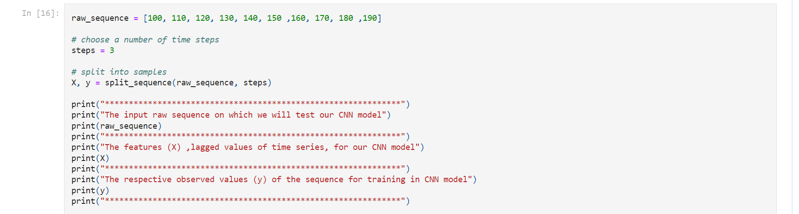

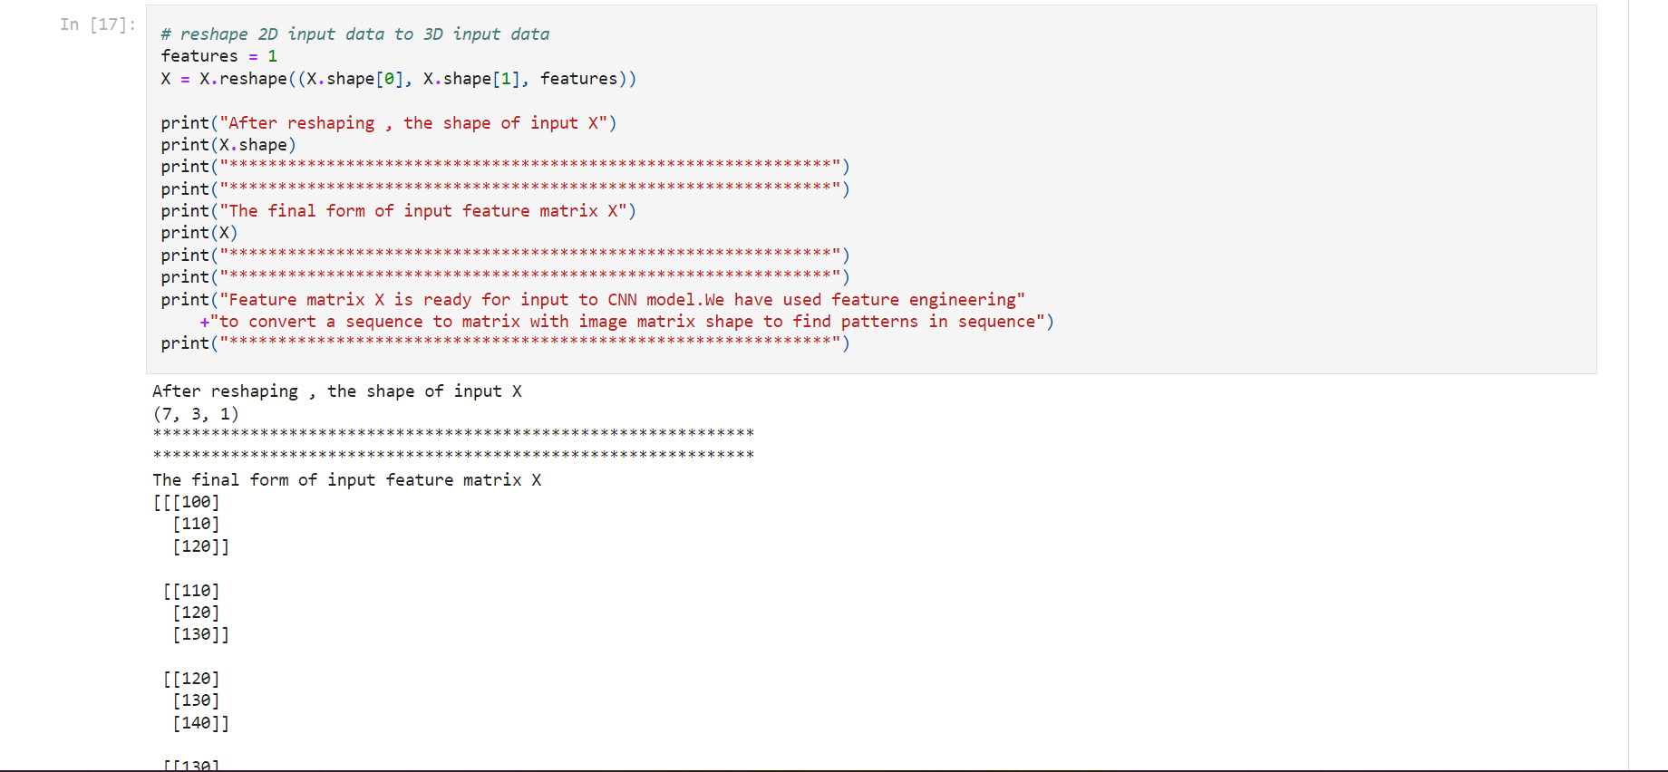

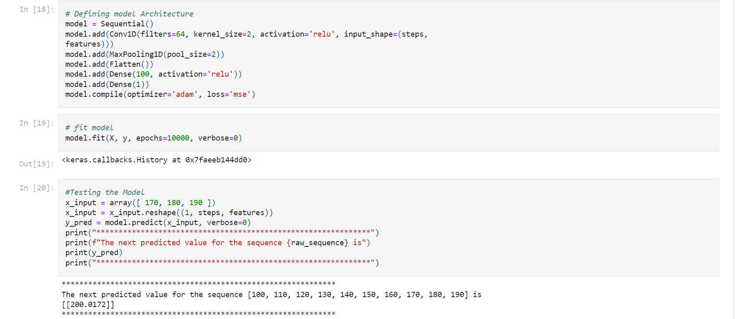

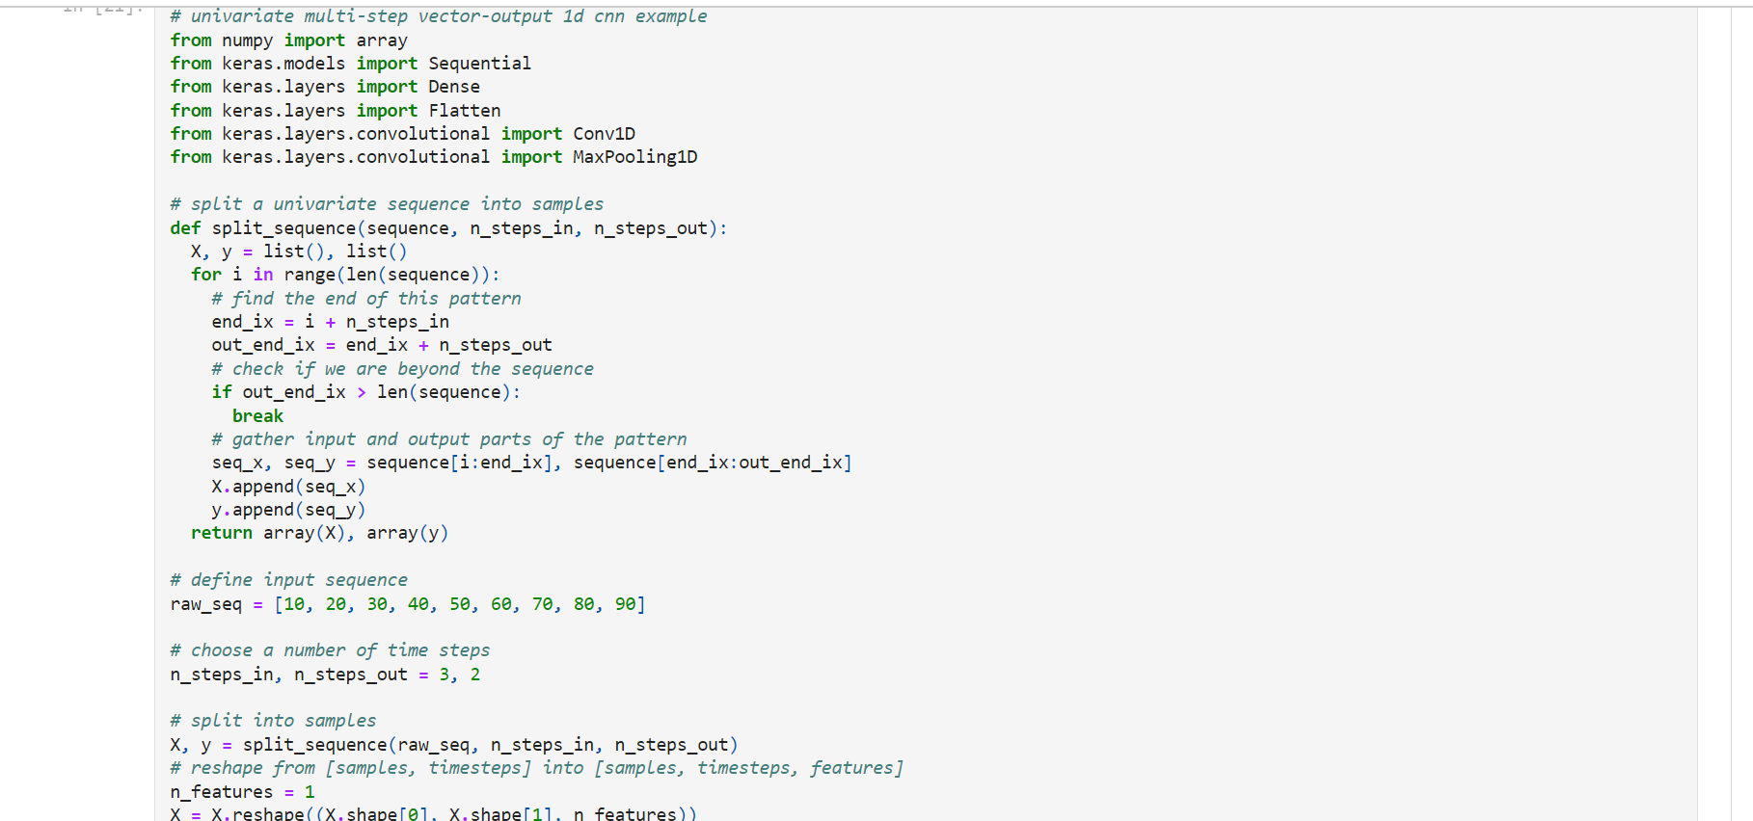

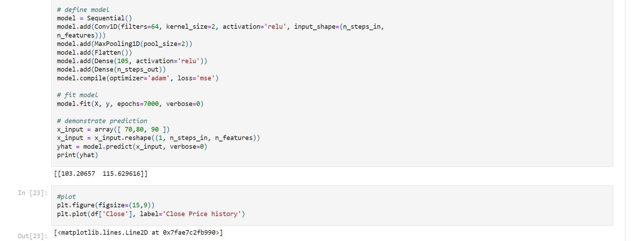

**LSTM:**

In this approach, recurrent neural networks were used to map the function between

sentiment values and the target price. Specifically, we used Long Short-Term Memory network as they were proven to be successful with text data. As the target variable we are predicting is either 0 or 1, this would be a classification problem. Therefore, architecture of the neural network is designed in such a way that it outputs a fully connected layer with softmax or sigmoid activationfunction. Architecture of the LSTM network is illustrated by the Figure 8 LSTM network architecture for textual analysis.

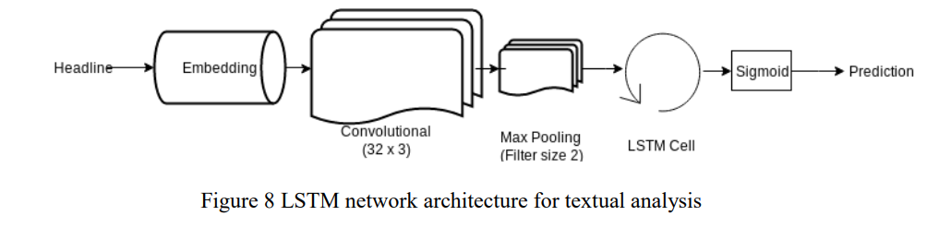

**Network:**

Input:

The news headlines are first preprocessed and passed as inputs to the neural network. During preprocessing, all non-alphabetical characters were removed and rest of the characters were decapitalized. Next word embeddings are calculated.

Word Embeddings: In NLP, word embeddings is a technique of representing words as vectors of real numbers in which words with similar meanings will have similar representation. This is one of the key breakthroughs in deep learning that achieved impressive performance for NLP problems. Words are represented in a distributed vector space based on their usage, and therefore words which are used similarly will have similar representation. First tokenizer takes the input words and indexes the text corpus based on word count, term frequency inverse document frequency (TFIDF). For indexing we store a maximum of 2000 words in the corpus. Therefore, the words which are not present in top 2000 will have the index set to 0. The headlines are transformed into vectors of fixed size of 100. If the headline is shorter than 100 words, zeros are padded to it. Then, these vectors are passed to an Embedding Layer in the neural network

**Convolutional Layer:**

A convolutional layer consists of a set of filters whose weights are learnt during the training process. Dimensions of the filter are spatially smaller than the input vector’s dimensions but will have the same depth. During a forward pass, the filters are slid over the width and height of the input vector and dot product is calculated between the values of the filter and the input at each position. The convolution process is shown in Figure 9, where I is the input vector and K is the filter. During the training process, network will learn these filters that activate when they see the target concealed in the input

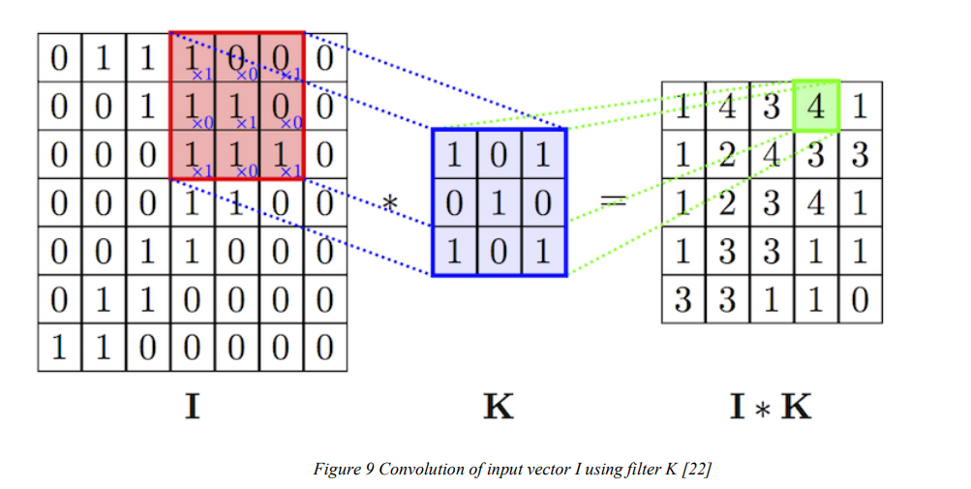

As we know convolutional layers are generally used for images as they are suitable for matrix representations. But as embedding vectors are also matrix representations of words, convolutional layers can be applied to word embeddings [23]. As images are more meaningful as a 2-dimensional representation than one dimensional array like representation, 2D convolution layer is used for images and for videos a 3D convolution layer is used. But in case of sentences (or words), a single dimension makes more sense than 2D or 3D. Therefore a 1-dimensional convolution layer is used for processing textual information.

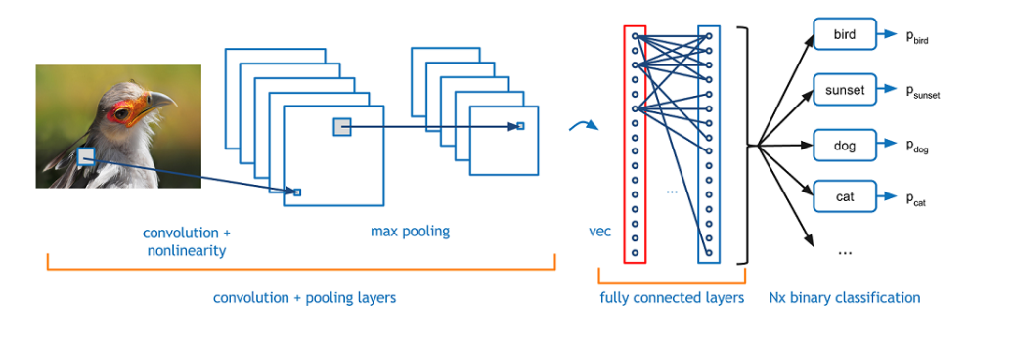

A typical convolutional neural network for image classification problem is shown in theFigure 10. In the above example the sliding window (called filter) scans over the image and transforms pixel information into a vector or matrix representation. Similarly, for sentences we use 1 dimensional layer as shown in Figure .In convolutional layers, a window or typically called as a filter, will be sliding over the input vector, at each step calculating convolution of the filter over data. To reflect the word negations, filter should consider the surrounding words to the current word. Therefore, we chose a kernel size of 3, so that word negations are accounted in the weights.

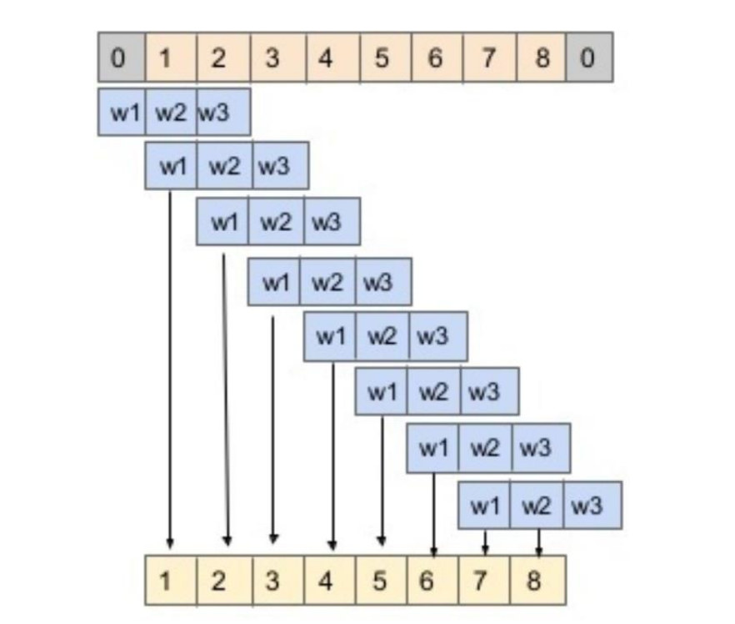

Metrics

Mean Squared Error:

Mean Squared Error (MSE) of an estimator measures the average of squares of the errors. The term error here denotes the difference between the actual value and the estimated value. Below equation denotes the mathematical equation for calculating the mean squared error.Here Yi represents the vector of the actual values and Y^i is the vector of predicted values.MSE is generally used when we have vectors with continuous values. We will be usingthis metric for comparing the results of the Numerical Analysis models and the merged model.

Accuracy:Accuracy of a binary classifier is a statistical measure of how well the classifier is able to predict the correct values. It is the percentage of true results among total number of samples. It is denoted by the below equation.

Accuracy = True Positives / Total number of predictions

Accuracy is a metric generally used for classification problems. As in textual analysis, we converted the problem of predicting exact stock prices to predicting whether the price increased or decreased, we can use the accuracy as the metric to evaluate the model.

**Results**

Step 1: Dataset Analysis

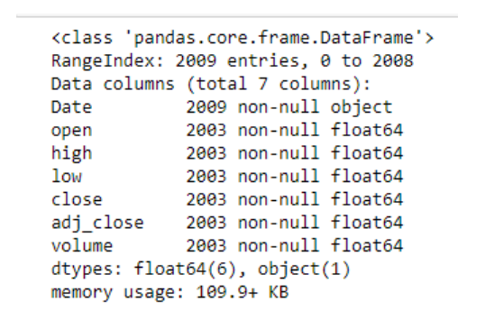

Firstly, I have performed Data analysis for stock price of companies. Fig. represent the date,

open, close, high, low, adjusted close and volume of stocks details.

Step 2: Read Dataset

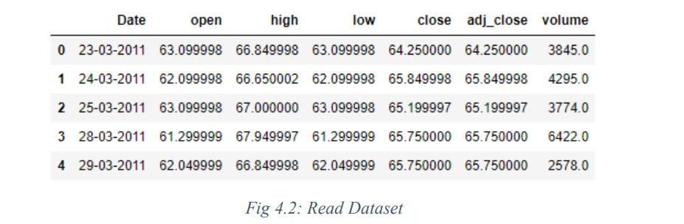

After performing data analysis, I have read the dataset. It shows the dataset information table

starting from the tail. There are 4274 data are available in each companies dataset.  
  
Step 3: Graph of Close Price history

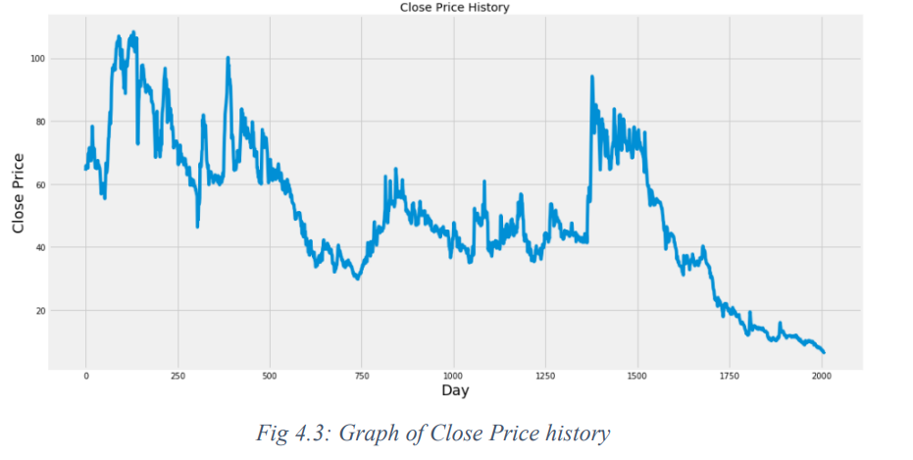

Step 4: Preprocessing

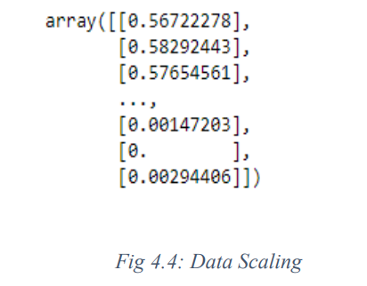

After Dataset reading, I have performed preprocessing operation on the dataset. Here I apply Min-Max Scaler to preprocess the dataset. In preprocessing operation removes the noise into the data and convert data into 0 to 1 form.

Step 5: Train test SplitAfter performing preprocessing, I have divided the dataset into training and testing set. 80% of the data is used for the training while the remaining 20% of the data is used for testing..

Step 6: Model fitting of Long Short Term Memory architecture[25] [26], Convolution Neural Network architecture[27] & Hybride Approach of LSTM+CNN.

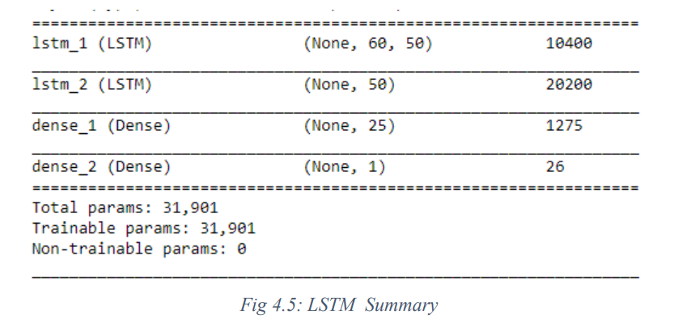

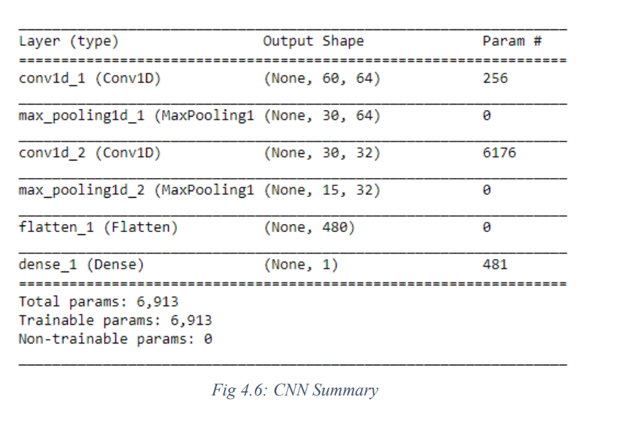

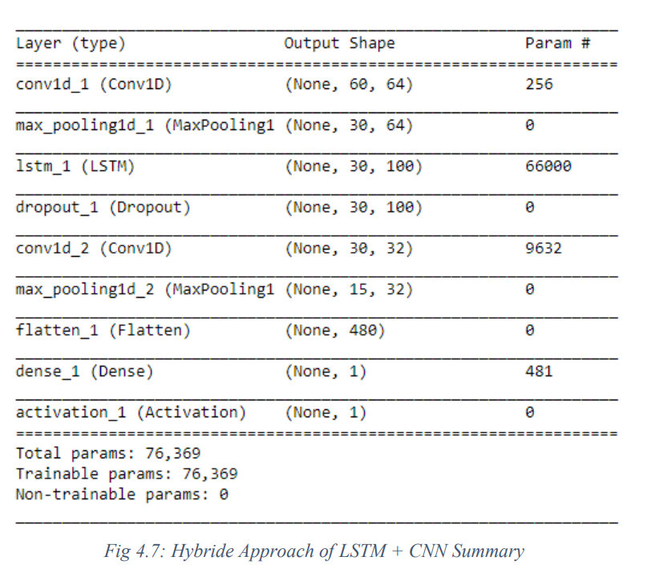

After generating training dataset, to apply training I have created LSTM, CNN & Hybride Approach of LSTM + CNN network using KERAS. several variations of this architecture using various numbers of layers and various size of Bottleneck layer.

Step 7: Apply Training  
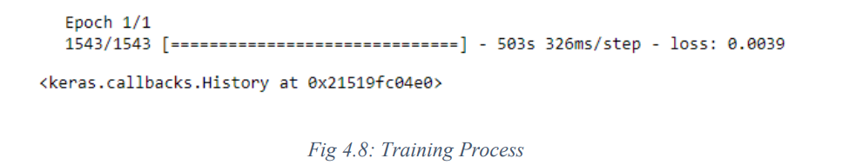

To apply training, from the samples of Training data, 1543 samples are used for training and 460 samples are used for validation. Data is processed in a batch size of 1 and epoch is 1 for the entire training dataset.

Step 8: Predicted Result  
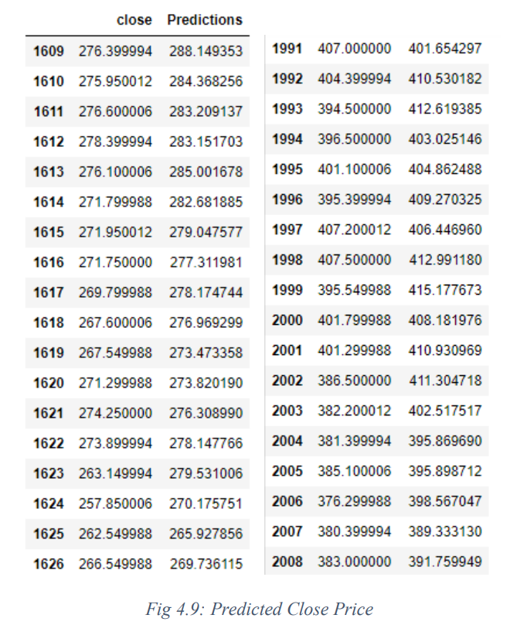

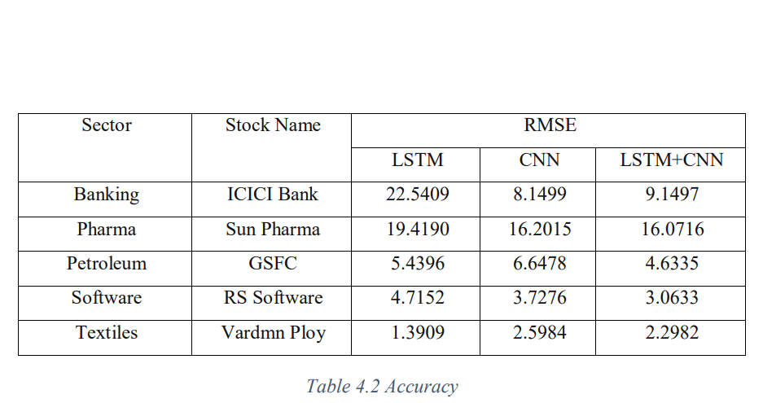

Step 9: Predicted Graph

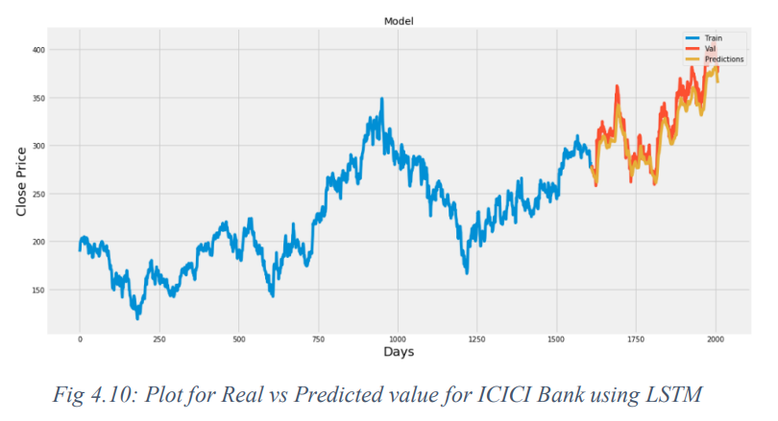

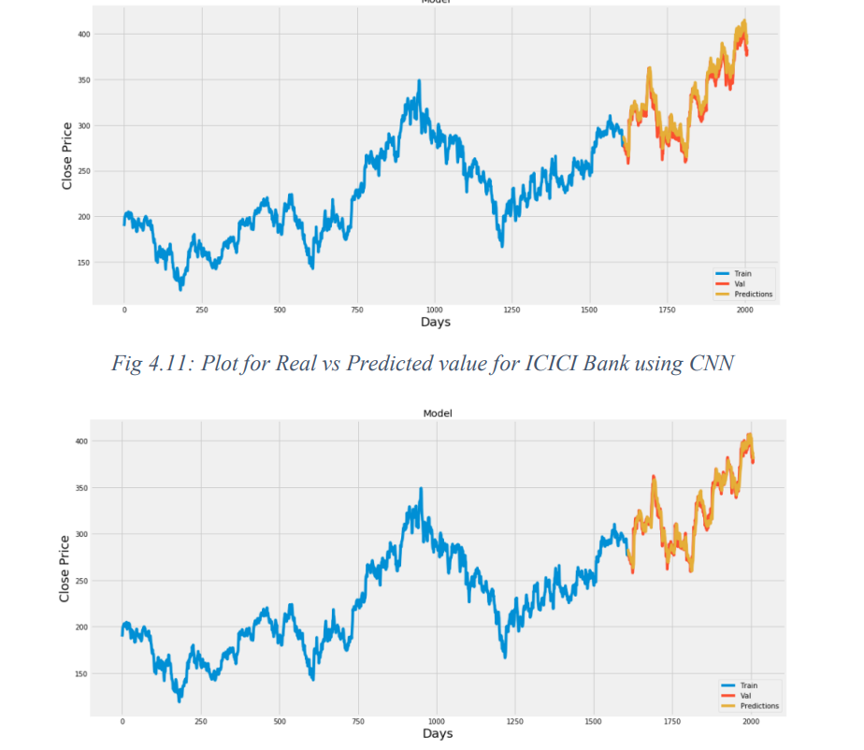

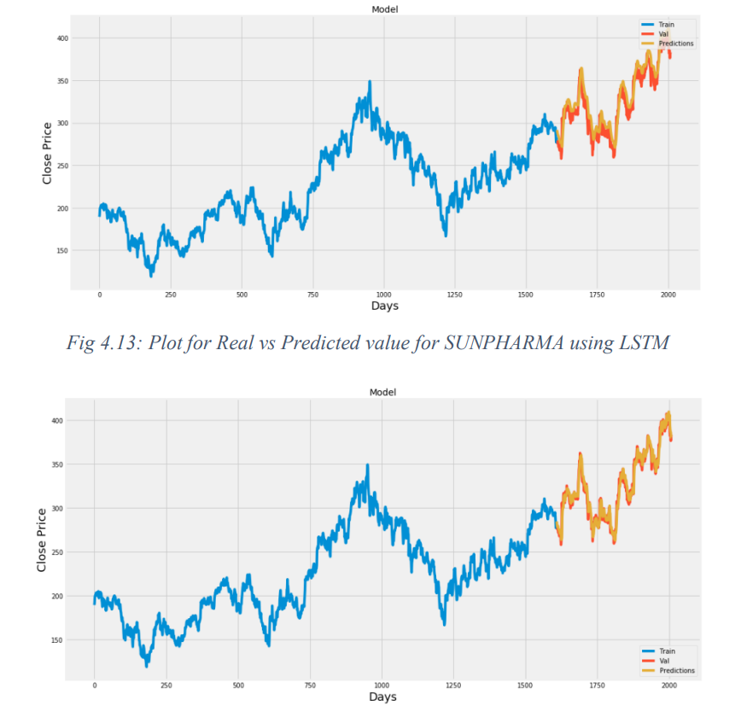

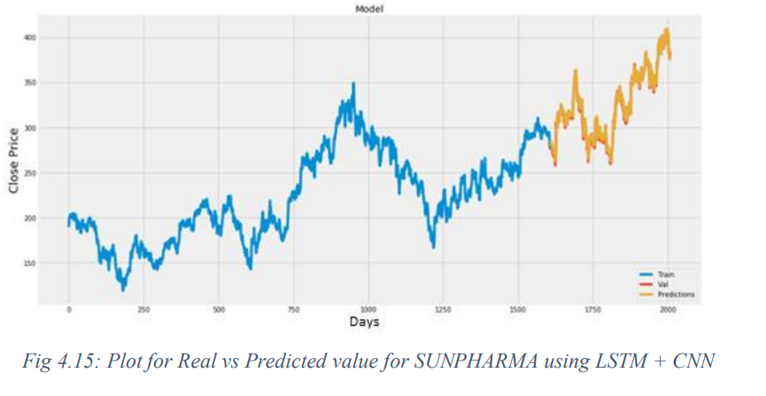

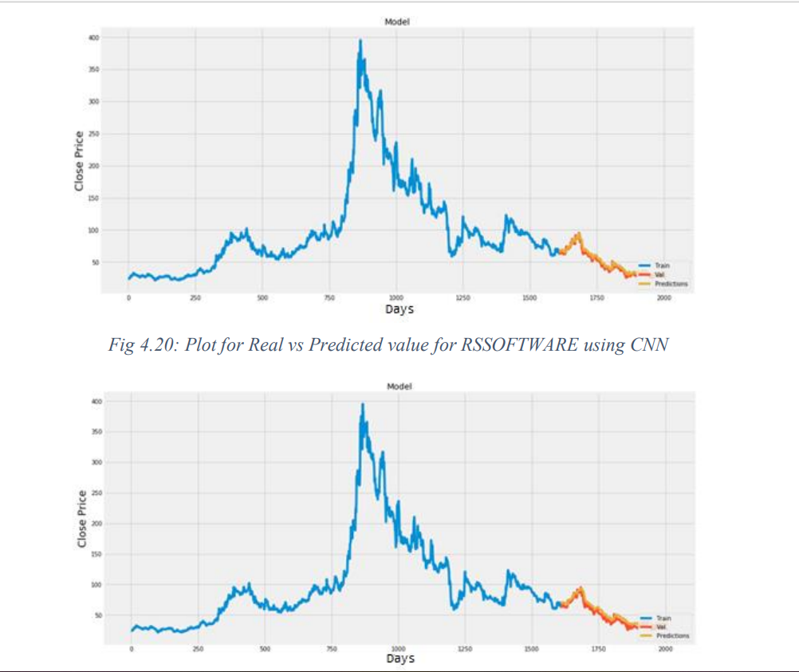

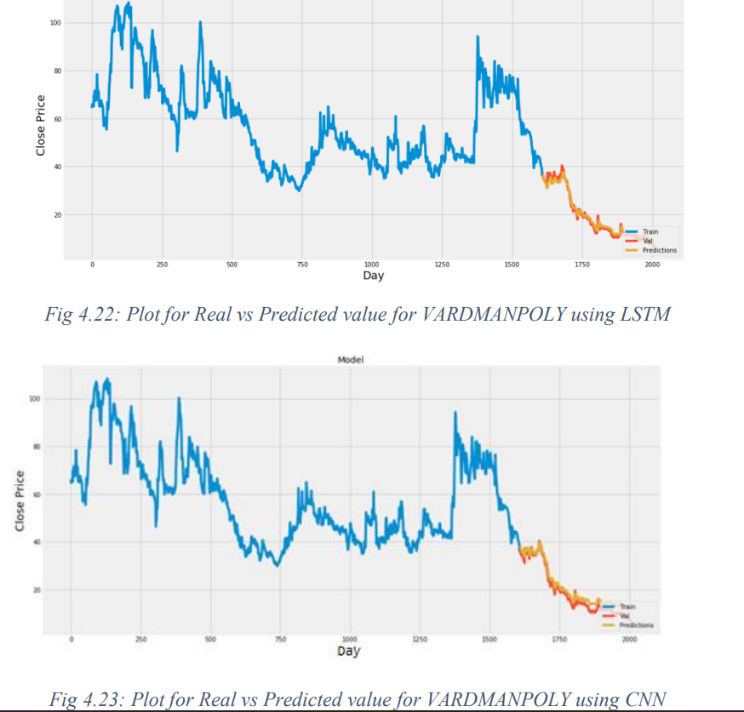

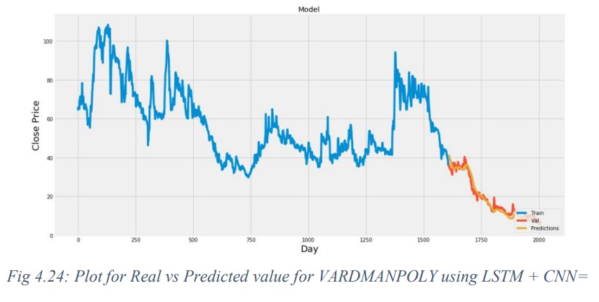

**Chapter 5**

Conclusion and Future Work

In report, we will compare a machine learning models like LSTM model, the CNN model and also the hybrid approach of LSTM + CNN model. We have a tendency to train the model using the data of NSE listed companies to predict the stock future value. This is shows the proposed method is capable to distinctive around interrelation with the data. Also, it is evident from the results that, Hybrid approach of LSTM+CNN model is capable to identify the changes in trends. For the projected method the Hybrid approach of LSTM+CNN is known as the best model. It uses the information given at a specific instant for prediction. Even if the other two models LSTM and CNN are utilized in a lot of other time-dependent data analysis, it is not outperforming over the Hybrid approach of LSTM+CNN architecture in this case. This is often because of quick changes occur in stock market. The changes in the stock market is not always be in a regular pattern or not always follow the continuous cycle. Based on the companies and sectors, the existence of the trends and the period of their existence will differ. The analysis of this type of cycles and trends can offer a more profit to the investors. In future work, we add more stock market data and compare more model to improve accuracy of predicted stock price.

In the future, for better accuracy model can be trained with more varied and detailed data. Also, other algorithms along with proposed can be used to create a new hybrid model.

**References**

[1] “Stock price prediction using LSTM, RNN and CNN-sliding window model - IEEE

Conference Publication.” https://ieeexplore.ieee.org/document/8126078 (accessed Dec.

27, 2019).

[2] J. Jagwani, M. Gupta, H. Sachdeva, and A. Singhal, “Stock Price Forecasting Using Data

from Yahoo Finance and Analysing Seasonal and Nonseasonal Trend,” in 2018 Second

International Conference on Intelligent Computing and Control Systems (ICICCS),

Madurai, India, Jun. 2018, pp. 462–467, doi: 10.1109/ICCONS.2018.8663035.

[3] I. Parmar et al., “Stock Dec. 2018, pp. 574–576, doi: 10.1109/ICSCCC.2018.8703332.

[4] Y. Lei, K. Zhou, and Y. Liu, “Multi-Category Events Driven Stock Price Trends

Prediction,” in 2018 5th IEEE International Conference on Cloud Computing and

Intelligence Systems (CCIS), Nanjing, China, Nov. 2018, pp. 497–501, doi:

10.1109/CCIS.2018.8691392.

[5] B. Jeevan, E. Naresh, B. P. V. kumar, and P. Kambli, “Share Price Prediction using

Machine Learning Technique,” in 2018 3rd International Conference on Circuits,

Control, Communication and Computing (I4C), Bangalore, India, Oct. 2018, pp. 1–4, doi:

10.1109/CIMCA.2018.8739647.

[6] M. Usmani, S. H. Adil, K. Raza, and S. S. A. Ali, “Stock market prediction using machine

learning techniques,” in 2016 3rd International Conference on computer and Information

Sciences (ICCOINS), 2016, pp. 322–327.

[7] J. Du, Q. Liu, K. Chen, and J. Wang, “Forecasting stock prices in two ways based on

LSTM neural network,” in 2019 IEEE 3rd Information Technology, Networking,

Electronic and Automation Control Conference (ITNEC), Mar. 2019, pp. 1083–1086, doi:

10.1109/ITNEC.2019.8729026.

[8] S. E. Gao, B. S. Lin, and C.-M. Wang, “Share Price Trend Prediction Using CRNN with

LSTM Structure,” in 2018 International Symposium on Computer, Consumer and Control

(IS3C), Dec. 2018, pp. 10–13, doi: 10.1109/IS3C.2018.00012.

[9] T. Gao, Y. Chai, and Y. Liu, “Applying long short term momory neural networks for

predicting stock closing price,” in 2017 8th IEEE International Conference on Software

Engineering and Service Science (ICSESS), Beijing, China, Nov. 2017, pp. 575–578, doi:

10.1109/ICSESS.2017.8342981

[10] R. Y. Nivetha and C. Dhaya, “Developing a Prediction Model for Stock Analysis,” in

2017 International Conference on Technical Advancements in Computers and

Communications (ICTACC), Melmaurvathur, India, Apr. 2017, pp. 1–3, doi:

10.1109/ICTACC.2017.11.

[11] Z. Yeze and W. Yiying, “Stock Price Prediction Based on Information Entropy and

Artificial Neural Network,” in 2019 5th International Conference on Information

Management (ICIM), Cambridge, United Kingdom, Mar. 2019, pp. 248–251, doi:

10.1109/INFOMAN.2019.8714662.

[12] “Basic LSTM Unit Transfer Function Diagram from [10] | Download Scientific

Diagram.” https://www.researchgate.net/figure/Basic-LSTM-Unit-Transfer-FunctionDiagram-from-10_fig8_308804546 (accessed Jun. 03, 2020).

[13] “Fig. 1: An example of CNN architecture.,” ResearchGate.

https://www.researchgate.net/figure/An-example-of-CNN-architecture_fig1_320748406

(accessed Jun. 03, 2020).

[14] Y. Kim, “Convolutional Neural Networks for Sentence Classification,” in Proceedings of

the 2014 Conference on Empirical Methods in Natural Language Processing (EMNLP),

Doha, Qatar, Oct. 2014, pp. 1746–1751, doi: 10.3115/v1/D14-1181.

[15] B. Athiwaratkun and K. Kang, “Feature Representation in Convolutional Neural

Networks,” ArXiv150702313 Cs, Jul. 2015, Accessed: Apr. 14, 2020. [Online]. Available:

http://arxiv.org/abs/1507.02313.

[16] F. A. Gers, D. Eck, and J. Schmidhuber, “Applying LSTM to Time Series Predictable

through Time-Window Approaches,” in Artificial Neural Networks — ICANN 2001,

Berlin, Heidelberg, 2001, pp. 669–676, doi: 10.1007/3-540-44668-0_93.

[17] J. Han and C. Moraga, “The Influence of the Sigmoid Function Parameters on the Speed

of Backpropagation Learning,” in Proceedings of the International Workshop on

Artificial Neural Networks: From Natural to Artificial Neural Computation, Berlin,

Heidelberg, Jun. 1995, pp. 195–201, Accessed: Apr. 13, 2020. [Online].

[18] “NSE Listed 1000+ Companies’ Historical Data.” https://kaggle.com/abhishekyana/nselisted-1384-companies-data (accessed Jul. 07, 2020).

[19] A. Tipirisetty, “Stock Price Prediction using Deep Learning,” p. 60.

[20] “Python Numpy Tutorial | Learn Numpy Arrays With Examples,” Edureka, Jul. 14, 2017.

https://www.edureka.co/blog/python-numpy-tutorial/ (accessed Apr. 21, 2020).

[21] “Scikit-learn Tutorial: Machine Learning in Python – Dataquest.”

https://www.dataquest.io/blog/sci-kit-learn-tutorial/ (accessed Apr. 21, 2020).